**\*(DO NOT EVER TOUCH THE GAVLO MIRRORS in any situation)**

If you are having problem adjust X/Y size via setting menu to your preference, you can adjust X/Y size via method 1:

First - set your setting for X/Y size to default 360 in the menu.

Open the left and right panels on Moai and remove build plate.

Run the circle calibration with no resin, no plate and empty clean vat with printed circle sheet

Use a small slotted screw driver (included in the kit) to adjust this screw on galvo driver board. Be very careful about it as a very small turn will affect the size of X/Y. Make sure to set X / Y Size to 90 in the system setting before you do this.

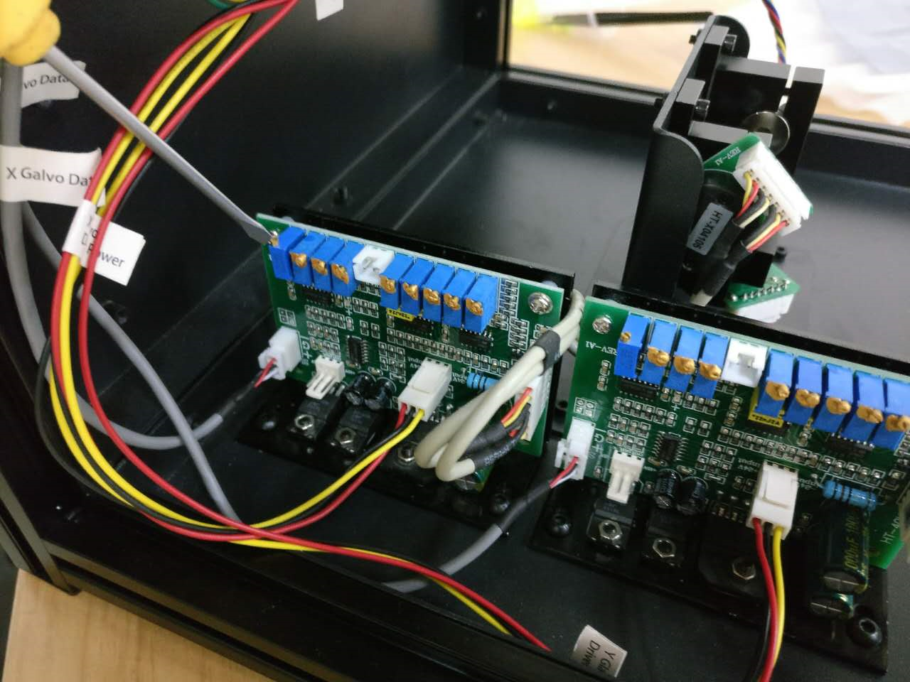

----

**DO NOT TOUCH TINY MIRRORS IN THE GALVO IN ANY CASE, SEE BELOW:**

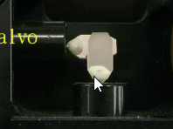

If you have hard time adjust X/Y position (location on the vat) through the X/Y Deviation in the setting menu, you can try following method:

First, set X/Y deviation to 100 in the setting menu

Open the left and right panels on Moai.

Run the circle calibration with no resin, no plate and empty clean vat with printed circle sheet

Use a small slotted screw driver (included in the kit) to loosen thess screw on galvo fixture. You can then turn the galvos by holding the motor part (where power cable is attached) to set its position while laser is scanning the circle. Be very careful about it as a very small turn will affect the deviation of X/Y greatly. And do not touch the mirror part of the Galov. See below picture:

